Foundations of Smart Manufacturing, Spring 2021 Paper Series

Recognition and Detection of Objects and Their Position for Robotic Grip Decision

Pavel Koprov

**---------------------------------------------------------------------------------------------------------------------------**

**Abstract**

The modern world demands high variability of products with high customization. Fast paces of technical development made small computing devices and robots available for small companies, but what is left out of the scene is a new framework for small companies to utilize the robots for custom orders. This can be easily done with the unique framework that allows robots to use low-cost cameras and machine learning (ML) models to detect the objects, their position and decide how to grasp the object. This allows the user to load the pile of parts on the "table" and let the robot assemble the product. In this paper, I attempt to tackle this problem using Raspberry PI and robots available at NCSU ISE labs.

***Keywords:*** position detection; grip decision for the robot; raspberry pi; low-cost camera; YOLO

**---------------------------------------------------------------------------------------------------------------------------**

1. Introduction

The modern world demands high variability of products with high customization [1]. Humans can produce products with significant variability, while automated lines are better suited to repetitive, monotonous work. On the other side, robots outperform human workers in speed, quality level, and labor cost. The optimal employee is a robot that can adjust to the environment and fast-changing objectives. This can be achieved through the implementation of machine vision and decision-making based on the retrieved information.

People work alongside robots, and this imposes a challenging task for robotics developers. The machines must be aware of surrounding objects, adjust to the part's non-standard orientation and know how to use them. Current technological progress rates bring the prices for computing devices really low, leading to widespread 'Smart' devices worldwide. Raspberry PI (RPI) is the corollary of this progress; more than 20 million of these low-cost computers have been sold worldwide [2]. Robotic vision systems can be built using RPIs and low-cost cameras. Many DIY materials on the internet show how to create simple object recognition and detection systems [3]–[5].

Object recognition is not a problem nowadays: different ML models outperform humans in object recognition accuracy [6], [7], and speed [8]. Nevertheless, they are either slower in the first case or not as accurate in the second case. Some commercial “Smart” cameras exist that have both advantages at the cost of a high price.

This paper aims to develop a prototype of a machine vision system that will consist of relatively cheap components and recognize the objects located in front of a camera. This system has to work quickly to timely decide how to grab the part with a mechanical grip.

1. Related work

There are different approaches to how the ML system decides which object is in front of it and its current position. [9] implemented a two-stage recognition approach. In their work, they used The Cornell Grasping Dataset [10], where the first stage was to detect the object and feed the result to the next model. The second stage defines the gripping area based on the detected object and the corresponding gripping area available for this object. Tsarouchi et al. [11] used a different approach where the object was predefined, but its position varied. They created labels for the predefined positions and used the ML model to extract a binary image and classify the position. This approach looks very robust in serial production, where the objects for the handling are not varying wildly. Besides, this approach utilizes 3D CAD model that corresponds to the position. Based on this information, the system decides how to grab the object. Kaymak et al. [12] implemented the actual performing prototype that was able to recognize objects, grab them and locate them in the desired bin. The drawback of this work is that the objects were simple, and the Z coordinate was fixed. Chatterjee et al. [13] used the modified YOLOv3 model to install it into a low-computing humanoid robot. It was capable of detecting the objects with high accuracy and speed. This work is a practical implementation of machine vision systems for simple and relatively cheap hardware. Pillai [14] developed a SLAM-supported object recognition system that improves the recognition based on time accumulated data. It outperforms the frame-based recognition in accuracy and provides the possibility to use a single camera to calculate the distance and update the information for the grip decision.

1. Methodology

In current work I will perform object detection using 2 frameworks: YOLOv4 and YOLOv4tiny. This framework uses DarkNet deep neural network (DNN) that sacrifices the accuracy in the cost of inference time. As the task for this project is not complicated and there is no complicated objects and the number of classes is not more than 10, the YOLO will be enough to perform the detection successfully. The full YOLOv4 uses 53 layers in the backbone whereas YOLOv4tiny uses only 9 [15]. This brings a much better accuracy to the bigger YOLO than the smaller but on contrary weights file is 10 times smaller for the tiny version.

The first step in creating a custom classifier is to collect the data. For this work I used the 5 different types of Mega BlocksTM provided to me by Dr. Starly. The list of blocks and corresponding labels is in the table 1. The pictures were collected via smartphone Samsung Galaxy S21 Ultra with different backgrounds. There were made approximately 30 pictures per each separate block with all different positions of blocks. Additionally, 46 pictures were made where all 5 objects were present. All pictures have different lighting, camera position and object positions. Labeling the pictures was performed on the platform roboflow.com, using their built-in labeling tool. This platform allows to resize all the images and create formatted label file specifically for the YOLO DarkNet format. Also, robolow.com allows to increase the dataset by adding modified source images. Modifications include Static Crop, Tile, Grayscale, Flip, Shear, Blur, Noise, etc. For this stage of the work none of the modifications were made and the dataset contained 200 images total.

The training of the models was performed using Google Colab platform and the Jupiter notebook created by Roboflow for YOLOv4 and YOLOv4 tiny: <https://colab.research.google.com/drive/1PkffxcLlp6tuAI7iW5bjDADl0RupSTvh>. Generated weights files were 24 Mb and 244 Mb for the full and tiny versions respectively. It took approximately 1.5 hours to train YOLOv4tiny with mAP = 98% and 4 hours to train YOLOv4 with the same mAP.

Table 1. List of objects.

|  |  |  |
| --- | --- | --- |
| Picture | Label | Description |
|  | 1x1_T_BL | 1x1 Tall block of blue color |
|  | 1x2_L_G | 1x2 Low block of green color |
|  | 2x2_L_Y | 2x2 Low block of yellow color |
|  | 1x3_T_R | 1x3 Tall block of red color |
|  | 1x4_T_LB | 1x4 Tall block of light blue color |

The inference of the detector was performed using the OpenCV in Python. The code allows to feed the image file, video file or the webcam stream to the detector and add receive the output file.

1. Results

Tiny YOLOv4 model shows the comparable to the full model results on an images and the videos where only the one object is located. When more than 3 objects are present the smaller model cannot recognize some of the objects or has a low confidence level. The full model performs much better than the smaller version but requires more computational resources. This can be crucial for the performance of the Raspberry PI.

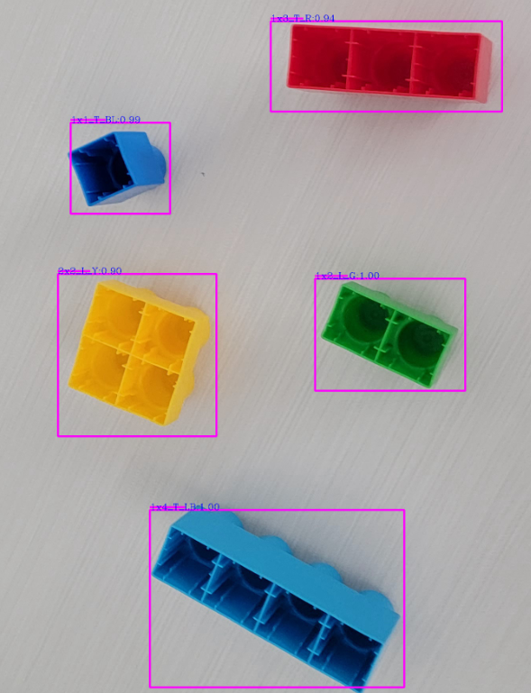 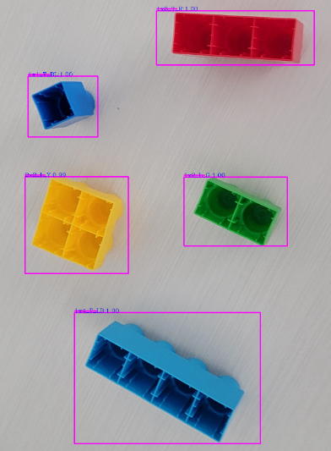

Picture 1. The result in confidence level for the YOLOv4Tiny and YOLOv4: the confidence level for the full YOLOv4 model is 100% for all the blocks except 2x2_L_Y (99%), whereas YOLOv4Tiny has 100% only for the 1x2_L_G and 1x4_T_LB (1x3_T_R 94%, 1x1_T_BL 99%, 2x2_L_Y 90%).

The results of the object detection can be used to perform the next stage – position detection. In this stage the bounding box becomes the input for the next stage of detection, where the model detects the positions of the block and gives a command to the robot to rotate its grip to align with the edges of the object.

Position detection can be performed without usage of the YOLO model and will perform faster with lower computation requirements.

References

[1] K. O’Marah, “Mass Customization and the Factory of the Future,” *IndustryWeek*, Jan. 14, 2015. https://www.industryweek.com/supply-chain/article/22008141/mass-customization-and-the-factory-of-the-future (accessed Mar. 11, 2021).

[2] “The Impact of Raspberry Pi,” *GeeksforGeeks*, Jan. 31, 2020. https://www.geeksforgeeks.org/the-impact-of-raspberry-pi/ (accessed Mar. 11, 2021).

[3] “How to easily Detect Objects with Deep Learning on Raspberry Pi,” *AI & Machine Learning Blog*, Nov. 14, 2018. https://nanonets.com/blog/how-to-easily-detect-objects-with-deep-learning-on-raspberry-pi/ (accessed Mar. 11, 2021).

[4] “Create a real-time object tracking camera with TensorFlow and Raspberry Pi | Opensource.com.” https://opensource.com/article/20/1/object-tracking-camera-raspberry-pi (accessed Mar. 11, 2021).

[5] “Running TensorFlow Lite Object Recognition on the Raspberry Pi 4,” *Adafruit Learning System*. https://learn.adafruit.com/running-tensorflow-lite-on-the-raspberry-pi-4/overview (accessed Mar. 11, 2021).

[6] “What I learned from competing against a ConvNet on ImageNet.” http://karpathy.github.io/2014/09/02/what-i-learned-from-competing-against-a-convnet-on-imagenet/ (accessed Mar. 11, 2021).

[7] R. Geirhos, D. H. J. Janssen, H. H. Schütt, J. Rauber, M. Bethge, and F. A. Wichmann, “Comparing deep neural networks against humans: object recognition when the signal gets weaker,” *arXiv:1706.06969 [cs, q-bio, stat]*, Dec. 2018, Accessed: Mar. 11, 2021. [Online]. Available: http://arxiv.org/abs/1706.06969.

[8] J. Redmon, S. Divvala, R. Girshick, and A. Farhadi, “You Only Look Once: Unified, Real-Time Object Detection,” *arXiv:1506.02640 [cs]*, May 2016, Accessed: Mar. 11, 2021. [Online]. Available: http://arxiv.org/abs/1506.02640.

[9] F. H. Zunjani, S. Sen, H. Shekhar, A. Powale, D. Godnaik, and G. C. Nandi, “Intent-based Object Grasping by a Robot using Deep Learning,” in *2018 IEEE 8th International Advance Computing Conference (IACC)*, Dec. 2018, pp. 246–251, doi: 10.1109/IADCC.2018.8692134.

[10] “cornell_grasp.” https://kaggle.com/oneoneliu/cornell-grasp (accessed Mar. 19, 2021).

[11] P. Tsarouchi, S.-A. Matthaiakis, G. Michalos, S. Makris, and G. Chryssolouris, “A method for detection of randomly placed objects for robotic handling,” *CIRP Journal of Manufacturing Science and Technology*, vol. 14, pp. 20–27, Aug. 2016, doi: 10.1016/j.cirpj.2016.04.005.

[12] C. KAYMAK and A. UCAR, “Implementation of Object Detection and Recognition Algorithms on a Robotic Arm Platform Using Raspberry Pi,” in *2018 International Conference on Artificial Intelligence and Data Processing (IDAP)*, Sep. 2018, pp. 1–8, doi: 10.1109/IDAP.2018.8620916.

[13] S. Chatterjee, F. H. Zunjani, S. Sen, and G. C. Nandi, “Real-Time Object Detection and Recognition on Low-Compute Humanoid Robots using Deep Learning,” *arXiv:2002.03735 [cs, stat]*, Jan. 2020, Accessed: Mar. 05, 2021. [Online]. Available: http://arxiv.org/abs/2002.03735.

[14] S. Pillai and J. Leonard, “Monocular SLAM Supported Object Recognition,” *arXiv:1506.01732 [cs]*, Jun. 2015, Accessed: Mar. 19, 2021. [Online]. Available: http://arxiv.org/abs/1506.01732.

[15] A. Bochkovskiy, C.-Y. Wang, and H.-Y. M. Liao, “YOLOv4: Optimal Speed and Accuracy of Object Detection,” *arXiv:2004.10934 [cs, eess]*, Apr. 2020, Accessed: Apr. 18, 2021. [Online]. Available: http://arxiv.org/abs/2004.10934.